Chapter 4, Problem 30.

Use source transformation on the circuit shown in Fig 4.98 to find i_{x}.

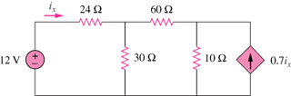

Figure 4.98
For Prob. 4.30.

